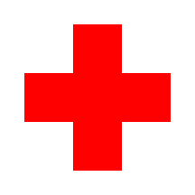
Indian Red Cross Society - Mumbai
AWMH, 8th floor, 1877, Dr. Anandrao Nair Marg,
Red Cross Street, Mumbai Central (East), Mumbai - 400011
Tel: 022-2309-6979
Email: info@ircsmumbai.org

Volunteer Enrollment Form

- Name of the Applicant: -

- Age:-

- Sex:-

- Education:-

Place of work / education

Contact Details :-

Res. Address:- --------------------------------------------------------------------------------

---------------------------------------------------------------------------------------------------

Land Line No. ----------------------------------
mob. ----------------------------------------

Email ID :-

- Association with Indian Red Cross Society:-

- Number of years of Experience:-

- Organization (other than Red Cross) :-

- Have you undergone any training?

a) Yes

b)No

8. If Yes, Training Name:-

a) Disaster Management

b) Red Cross Volunteer

c) HIV & AIDS

d) Life

skills

e) Other

9. Which type of work have you done with Indian Red Cross Society?

10. Area of Interest as a volunteer:-

a) Education

b)Health

c) Environmental Awareness

d) Disaster

e) HIV & AIDS

f) Physiological support group

g) Emblem awareness

  - Fund raising i) any kind of Training

- How much time are you willing to commit to organization?

a) 1 Day in month d) More than in year

b) 1 Day in Week c) 1 Month in year e) only in emergency / disaster

I agree to work as a volunteer for Red Cross & attend necessary training.

Date Signature

